A Project Report On

**MUSIC APP**

Submitted in partial fulfillment of the requirement for the award of the degree

Bachelor of Computer Application

BCA

Academic Year 2025 – 26

**Jatin sanghani Tushar Khokhar Meetraj Sinh**

**92300527019 92300527020 92300527121**

|  |
| --- |
| **Internal Guide** |
| Prof. Riddhi Joshi |



Rajkot-Morbi Road, At & PO : Gauridad, Rajkot 360 003. Gujarat. India.

**Faculty of Computer Applications (FCA)**



**This is to certify that the project work entitled**

**MUSIC APP**

**submitted in partial fulfillment of the requirement for**

**the award of the degree of**

**Bachelor of Computer Application**

BCA

**of the**

**Marwadi University**

**is a result of the bonafide work carried out by**

**Jatin sanghani – 92300527019**

**Tushar Khokhar – 92300527020**

**Meetraj Sinh – 92300527121**

**during the academic year 2025-26**

|  |  |  |  |  |
| --- | --- | --- | --- | --- |
| **Faculty Guide** |  | **HOD** |  | **Dean** |

**DECLARATION**

We hereby declare that this project work entitled **“Music App”** is a record of original work done by us.

We further declare that the matter embodied in this project has not been submitted to this or any other university or institute for the fulfillment of any course of study.

Place :

Date :

**Jatin sanghani 92300527019 Signature :**

**Tushar khokhar 92300527020 Signature :**

**Meetraj sinh 92300527121 Signature :**

**CONTENTS**

|  |  |  |
| --- | --- | --- |
| **Chapters** | **Particulars** | **Page No.** |
| **1** | **SYNOPSIS** | 5 |
| **2** | **PREAMBLE**  General Introduction  Module description | 6 |
| **3** | **TECHNICAL DESCRIPTION**  Hardware Requirement  Software Requirement | 8 |
| **4** | **SYSTEM DESIGN AND DEVELOPMENT**  **(Only applicable diagrams)**   * ER Digram, Use Case Diagram, * Screen Design & Coding | 9 |
| **5** | **CONCLUSION** | 25 |
| **6** | **LEARNING DURING SIP** | 25 |
| **7** | **BIBLIOGRAPHY**  Online References  Offline References | 26 |

**SYNOPSIS**

**Title of the Project:**  
**Music App**

**Objective of the Project:**  
To develop a Flask-based web application that provides a seamless platform for users to stream music, create personalized playlists, and for administrators to manage the music library efficiently.

**Scope of the Project:**

* Designed for music lovers and administrators.
* Allows users to browse songs by category, play audio, and manage personal playlists.
* Enables admins to perform full CRUD operations on songs and categories.
* Features a responsive, dark-themed UI built with Bootstrap.

**Tools & Technologies Used:**

* **Backend:** Python, Flask
* **Frontend:** HTML5, CSS3, Bootstrap 5, JavaScript
* **Database:** SQLite
* **Libraries:** Flask, SQLite3

**Modules of the Project:**

1. **User Authentication:** User registration, login, and session management.
2. **Music Management (Admin):** Add, edit, delete, and categorize songs.
3. **Music Player:** Frontend audio player for streaming music.
4. **Playlist Management:** Users can create playlists and add/remove songs.
5. **Category Management:** Admin can create and manage song categories.

**PREAMBLE**

**General Introduction:**

The **Music App** is a modern web-based platform built to cater to the growing demand for personalized music experiences. In an era dominated by digital media, this project provides a centralized system for organizing and streaming music collections.

The application features a dual interface:

* A **user-friendly portal** for listeners.
* A **powerful dashboard** for administrators.

Built with the **Flask framework**, it emphasizes simplicity, performance, and responsive design that works across devices. The **dark-themed UI** reduces eye strain, making it ideal for prolonged use.

**Module Descriptions:**

* **User Authentication Module:** Secure sign-up, login, and session management.
* **Admin Dashboard Module:** Comprehensive control of the music library with CRUD operations.
* **Category Management Module:** Allows admins to create and organize genres/moods.
* **Music Player Module:** Integrated HTML5 audio player for seamless playback.
* **Playlist Management Module:** Lets users create, manage, and enjoy custom playlists.
* **Add Song Module:** Dedicated admin page for uploading new songs with metadata and audio file.

**TECHNICAL DESCRIPTION**

**Hardware Requirements:**

* Processor: Intel i3 or equivalent
* RAM: 4 GB minimum
* Hard Disk: 500 MB free space
* Display: 1366x768 resolution or higher

**Software Requirements:**

* Operating System: Windows 10/11, Linux, or macOS
* Python Version: 3.8+
* Web Browser: Chrome, Firefox, Edge (latest)
* IDE: VS Code, PyCharm, or any text editor

**ER Diagram:**

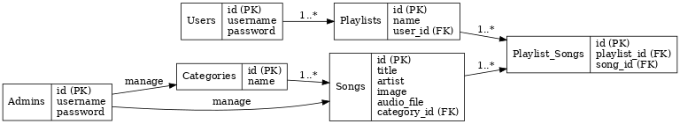

**Diagram:**

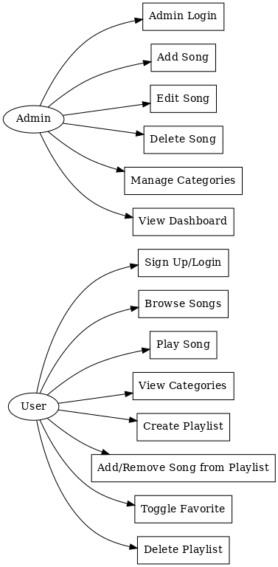

**Screen Design & Coding**

**LOGIN PAGE**

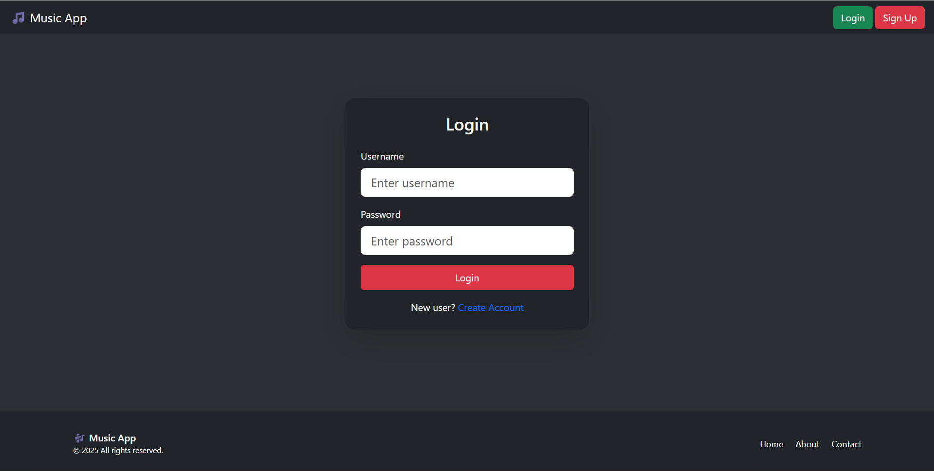

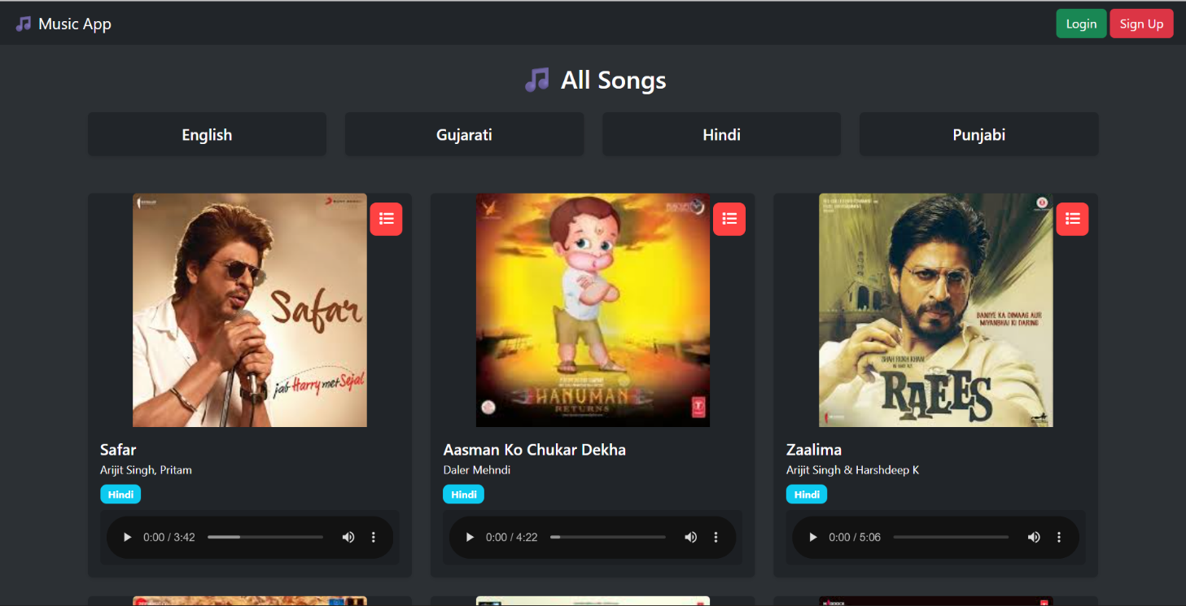**Main Interface**

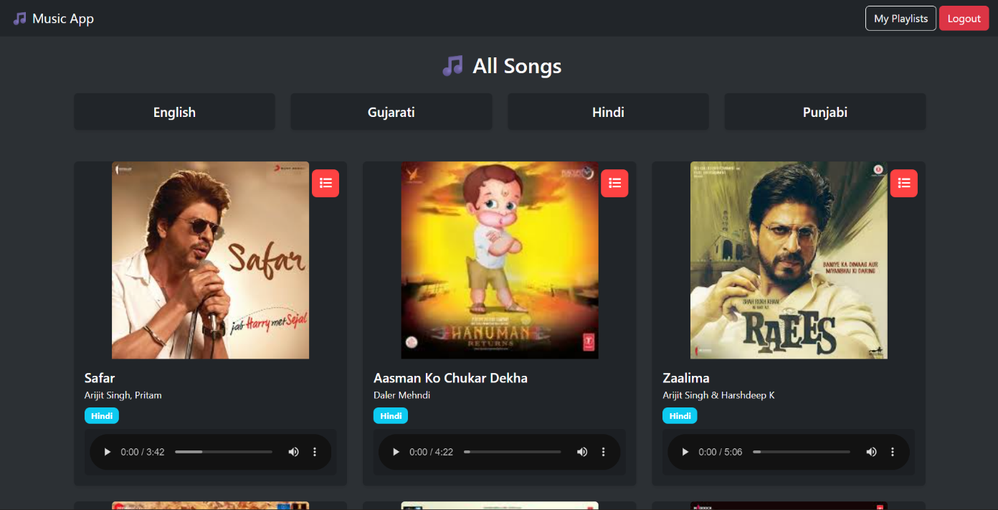**After User Login :**

**Create Playlist:**

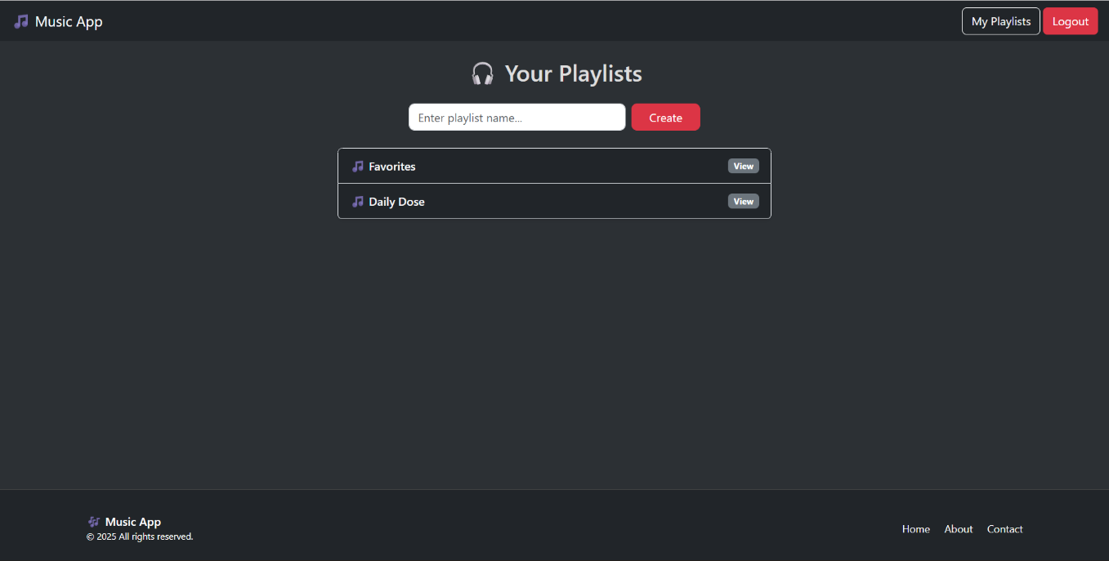

**Playlists :**

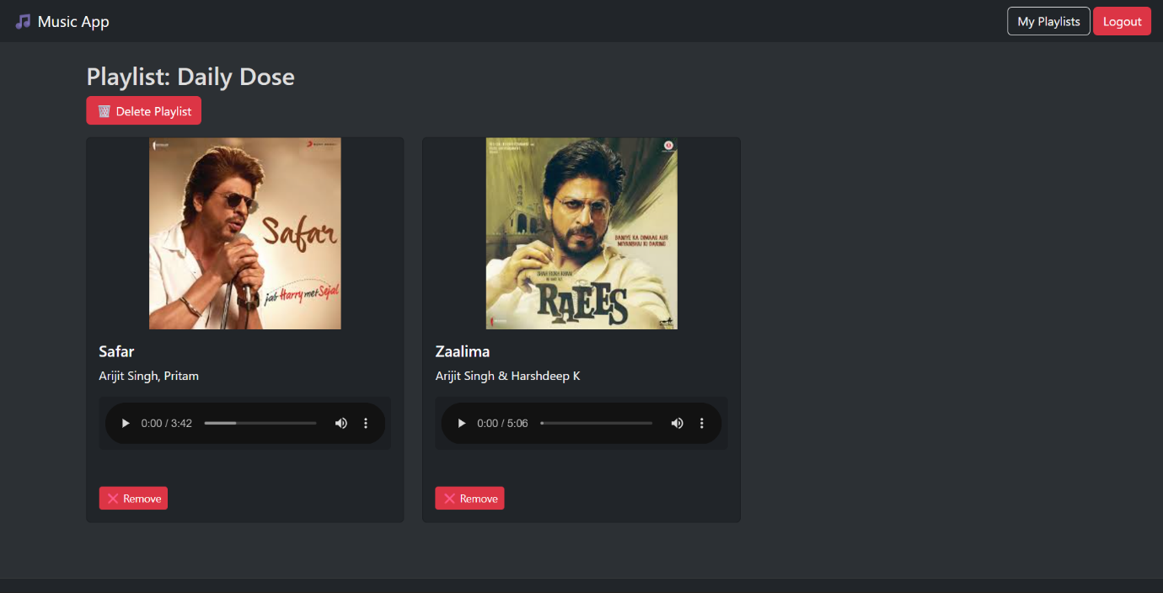

**Admin Login :**

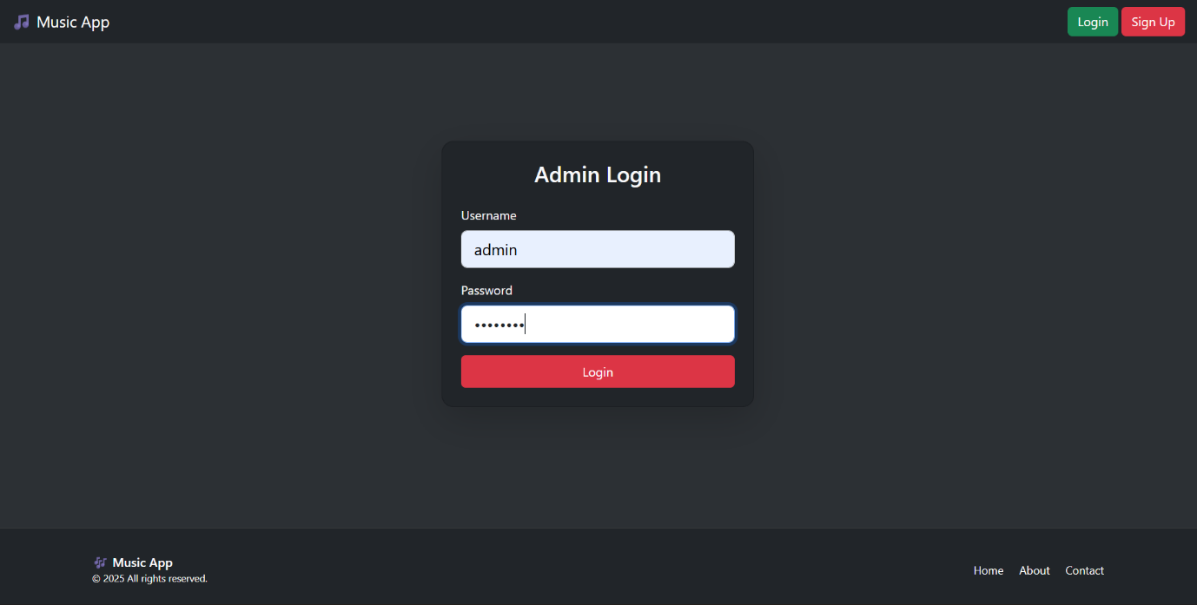

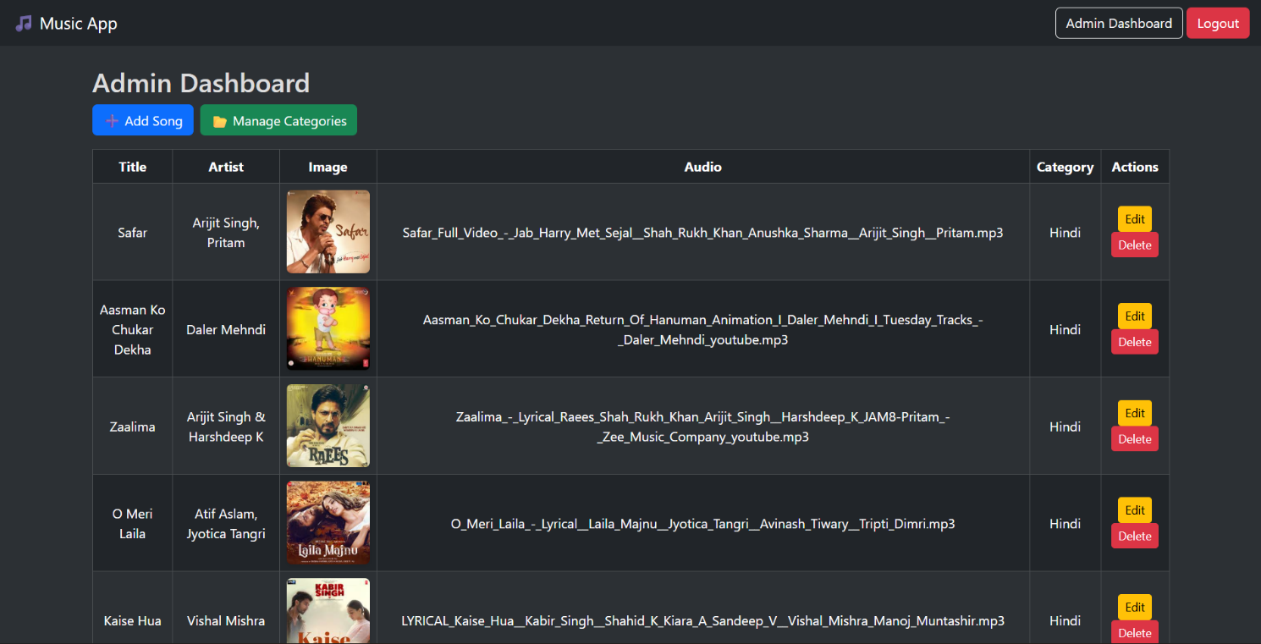**Admin Dashboard :**

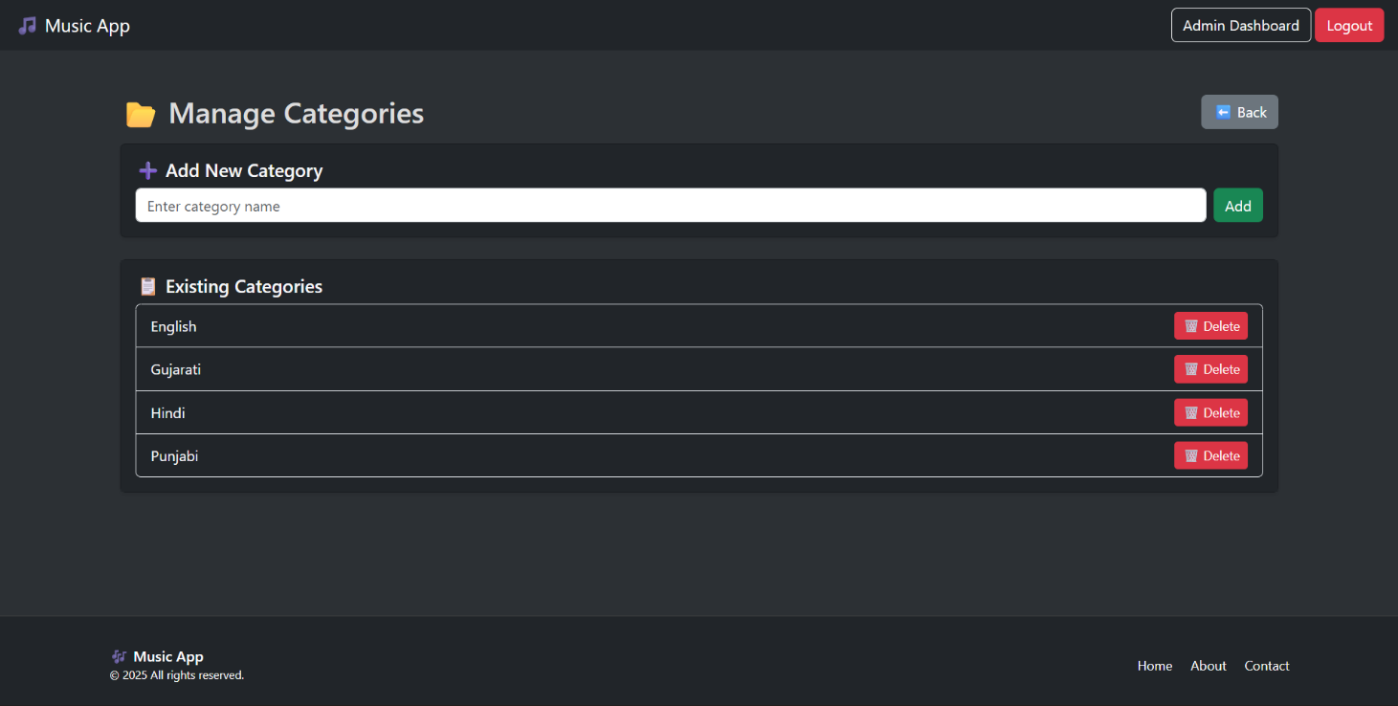**Manage Categories:**

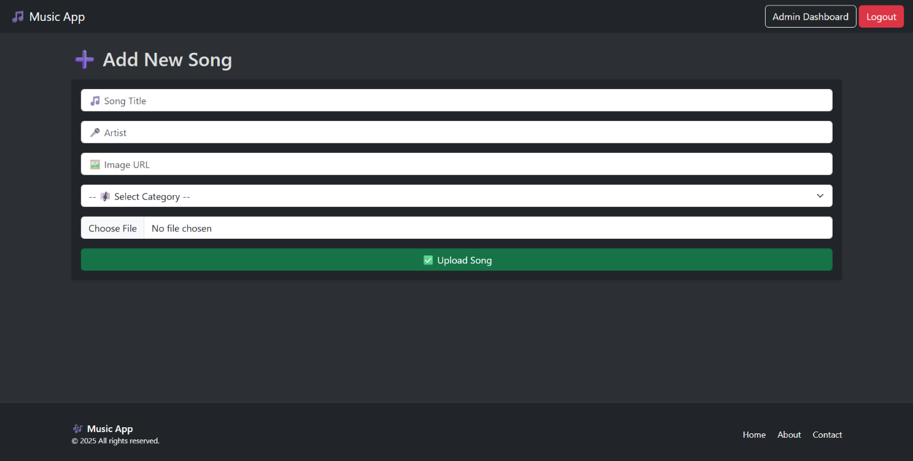 **Add Music :**

**CONCLUSION :**

The Music Streaming Web Application demonstrates the integration of **Flask (backend)** with **Bootstrap (frontend)** to create a functional and visually appealing web app.

This project enhanced knowledge of:

* Database design,
* Session management,
* Full-stack web development,
* Responsive UI.

Future enhancements could include:

* Song recommendations,
* User profiles,
* Social sharing,
* Advanced audio visualization.

**LEARNING DURING SIP**

* Mastered Flask web framework.
* Designed relational database schemas.
* Improved UI design with Bootstrap.
* Implemented authentication & session handling.
* Enhanced debugging & problem-solving skills.
* Learned modular project structuring.

**BIBLIOGRAPHY**

**Online References:**

* Flask Documentation – [https://flask.palletsprojects.com/](https://flask.palletsprojects.com/?utm_source=chatgpt.com)
* Bootstrap Documentation – [https://getbootstrap.com/docs/5.3/](https://getbootstrap.com/docs/5.3/?utm_source=chatgpt.com)
* SQLite Documentation – [https://www.sqlite.org/docs.html](https://www.sqlite.org/docs.html?utm_source=chatgpt.com)
* MDN Web Docs (Audio Element) – [https://developer.mozilla.org/en-US/docs/Web/HTML/Element/audio](https://developer.mozilla.org/en-US/docs/Web/HTML/Element/audio?utm_source=chatgpt.com)

**Offline References:**

* Classroom lectures & notes on Python and Web Technologies.
* Guidance from faculty and project guide.
* Reference books on Python programming & web development.

**\*\* THANK YOU \*\***